**Static Page for SRKW call catalogue browsing**

* Static page – items will be rendered using backend python scripts in the future (including the paging part)

**Mock-up and Logics**

1. **Main Page**

**SRKW Call Catalogue**

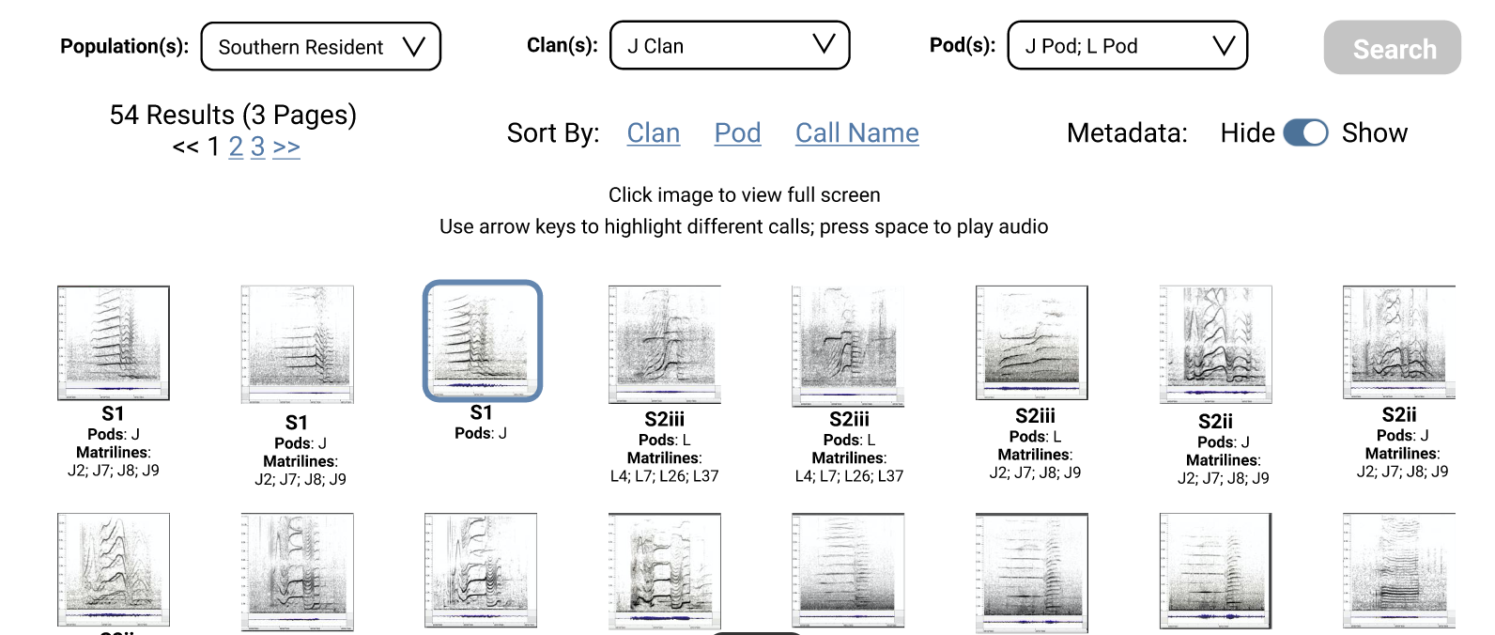





* Filtering / Searching / Sorting

|  |  |  |
| --- | --- | --- |
| Field Names | Possible Values | Remarks |
| Population | * Southern Resident (Default) * Northern Resident * Transient | Single Selection |
| Clan(s) | * J | Single Selection |
| Pod(s) | * J * K * L | Single Selection |

* Call catalogue item

Full Data List



|  |  |  |  |
| --- | --- | --- | --- |
| Fields | Label | JSON Key | Example Values |
| filename  (same file name for both image and wav file) |  | filename => shared name  thumb => image file full name | * BCS01-J01pod-J02,J07,J08andJ09mat-1.jpg * BCS01-J01pod-J02,J07,J08andJ09mat-1.wav |
| clan | Clan | clan | J (default and only value) |
| pod | Pod text | pod | Please refer to list in srkw_call_data.csv  e.g. J01pod |
| pod_category | Pod(s) | pod_cat | e.g. [J,K]  Selection via pull down menu:   * J * K * L |
| callname | Call Name | cn | BCS05, BCS02iii |
| matrilines | Matriline | mar | Please refer to list in srkw_call_data.csv |

* Actions
* On clicking the image
  + Highlight the image
  + Display Pop Up
    - Enlarged picture
    - Play button with audio player
    - Close button to close the window and return to main page

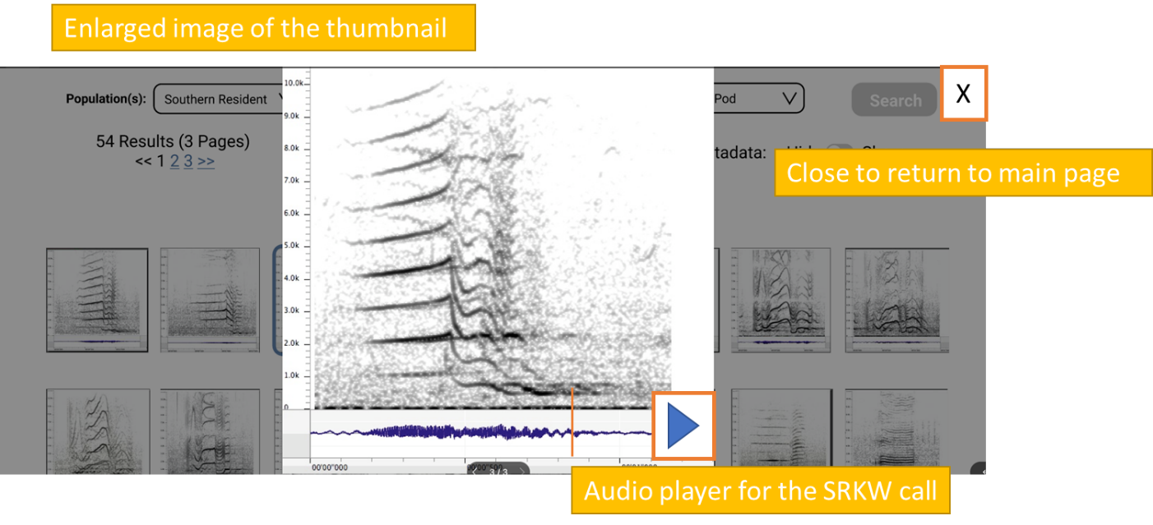

* On clicking the Play button
  + Play the audio
* Resizing the images and the number of images (records) displayed)
* Changing to list view

**References**

**Audio file player library reference provided:**

<https://gitlab.meridian.cs.dal.ca/public_projects/specviz/-/tree/development>

<https://wavesurfer-js.org/>

**Other UI references provided:**

Sample code:

<https://codepen.io/tutsplus/details/KLXpdm>

Tutorial:

<https://webdesign.tutsplus.com/tutorials/how-to-build-a-filterable-thumbnail-layout-with-css-grid-flexbox-and-javascript--cms-33242?fbclid=IwAR0ydA1P1vGa7wZfltFX0MCp8AuJ8tAppa7_6XVscrmm9qByxBUc-O8b_xo>

Marine Mammal quiz:

<https://data.meridian.cs.dal.ca/>